**User Guide: PX4 Autopilot Simulink Interface**

**Notices**:

*Copyright* ***2018****, United States Government as represented by the Administrator of the National Aeronautics and Space Administration. All Rights Reserved.*

MAVLINK__________________________________________

Portions of this software were generated using Mavlink (<https://github.com/mavlink>) and are subject to the following MIT License: Permission is hereby granted, free of charge, to any person obtaining a copy of the generated software (the "Generated Software"), to deal in the Generated Software without restriction, including without limitation the rights to use, copy, modify, merge, publish, distribute, sublicense, and/or sell copies of the Generated Software, and to permit persons to whom the Generated Software is furnished to do so, subject to the following conditions:

The above copyright notice and this permission notice shall be included in all copies or substantial portions of the Generated Software.

THE GENERATED SOFTWARE IS PROVIDED "AS IS", WITHOUT WARRANTY OF ANY KIND, EXPRESS OR IMPLIED, INCLUDING BUT NOT LIMITED TO THE WARRANTIES OF MERCHANTABILITY, FITNESS FOR A PARTICULAR PURPOSE AND NONINFRINGEMENT.  IN NO EVENT SHALL THE AUTHORS OR COPYRIGHT HOLDERS BE LIABLE FOR ANY CLAIM, DAMAGES OR OTHER LIABILITY, WHETHER IN AN ACTION OF CONTRACT, TORT OR OTHERWISE, ARISING FROM, OUT OF OR IN CONNECTION WITH THE GENERATED SOFTWARE OR THE USE OR OTHER DEALINGS IN THE GENERATED SOFTWARE.

**NASA Disclaimers**

No Warranty: THE SUBJECT SOFTWARE IS PROVIDED "AS IS" WITHOUT ANY WARRANTY OF ANY KIND, EITHER EXPRESSED, IMPLIED, OR STATUTORY, INCLUDING, BUT NOT LIMITED TO, ANY WARRANTY THAT THE SUBJECT SOFTWARE WILL CONFORM TO SPECIFICATIONS, ANY IMPLIED WARRANTIES OF MERCHANTABILITY, FITNESS FOR A PARTICULAR PURPOSE, OR FREEDOM FROM INFRINGEMENT, ANY WARRANTY THAT THE SUBJECT SOFTWARE WILL BE ERROR FREE, OR ANY WARRANTY THAT DOCUMENTATION, IF PROVIDED, WILL CONFORM TO THE SUBJECT SOFTWARE. THIS AGREEMENT DOES NOT, IN ANY MANNER, CONSTITUTE AN ENDORSEMENT BY GOVERNMENT AGENCY OR ANY PRIOR RECIPIENT OF ANY RESULTS, RESULTING DESIGNS, HARDWARE, SOFTWARE PRODUCTS OR ANY OTHER APPLICATIONS RESULTING FROM USE OF THE SUBJECT SOFTWARE.  FURTHER, GOVERNMENT AGENCY DISCLAIMS ALL WARRANTIES AND LIABILITIES REGARDING THIRD-PARTY SOFTWARE, IF PRESENT IN THE ORIGINAL SOFTWARE, AND DISTRIBUTES IT "AS IS."

 Waiver and Indemnity:  RECIPIENT AGREES TO WAIVE ANY AND ALL CLAIMS AGAINST THE UNITED STATES GOVERNMENT, ITS CONTRACTORS AND SUBCONTRACTORS, AS WELL AS ANY PRIOR RECIPIENT.  IF RECIPIENT'S USE OF THE SUBJECT SOFTWARE RESULTS IN ANY LIABILITIES, DEMANDS, DAMAGES, EXPENSES OR LOSSES ARISING FROM SUCH USE, INCLUDING ANY DAMAGES FROM PRODUCTS BASED ON, OR RESULTING FROM, RECIPIENT'S USE OF THE SUBJECT SOFTWARE, RECIPIENT SHALL INDEMNIFY AND HOLD HARMLESS THE UNITED STATES GOVERNMENT, ITS CONTRACTORS AND SUBCONTRACTORS, AS WELL AS ANY PRIOR RECIPIENT, TO THE EXTENT PERMITTED BY LAW.  RECIPIENT'S SOLE REMEDY FOR ANY SUCH MATTER SHALL BE THE IMMEDIATE, UNILATERAL TERMINATION OF THIS AGREEMENT.

**This document is an overview of the PX4 Autopilot Simulink Interface.**

The interface is implemented in C code which is then compiled to generate a Simulink S-Function. In Simulink a user defined S-Function block can be added and the generated S-Function name “PX4” can be specified as the “S-Function name:” parameter. Below is an example of this block. This block’s file name is “PX4.slx”.

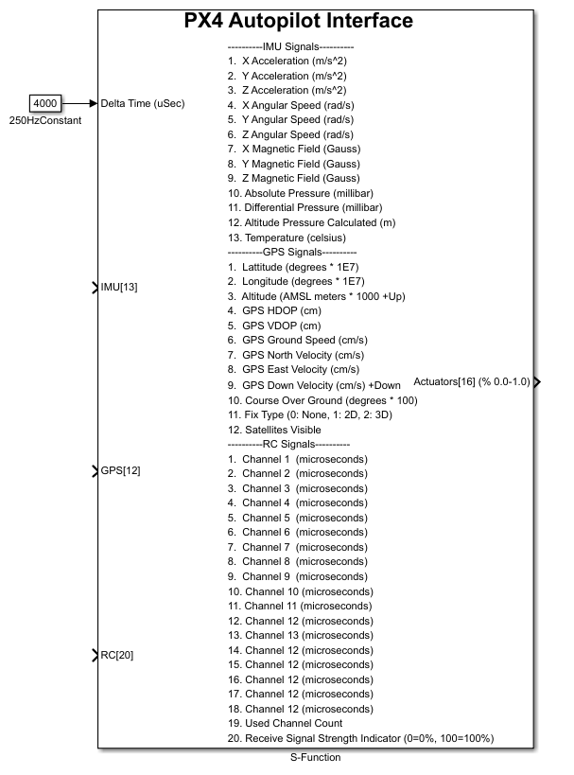

The Simulink PX4 Autopilot Interface C code consist of 2 main files; PX4Main.c and PX4Interface.h. The PX4Interface.h file declares the functions that the Simulink S-Function accesses when a simulation is running. There are 2 functions that the S-Function accesses; start and step. The start function is called when the Simulink simulation starts, and sets up the required communications functionality to interface with a software in the loop (SITL) PX4 autopilot over UDP on an IP network. The step function is called every cycle of the Simulink simulation. It sends senor measurement values from the Simulink simulation model to the SITL PX4 autopilot and receives actuator command values from the SITL PX4 autopilot.

A third file, BuildPX4Interface.m is utilized to compile and generate the Simulink S-Function. When this file is run, it invokes the C code compiler that is install on the computer. This generates 2 files; PX4.c and PX4.mexw64. This script must be run to generate the files in order for the Simulink S-function to work correctly.

Note: The current C code implementation only has support for running on a Windows machine.

Note: All testing has be conducted with Microsoft Visual Studios compiler install on the computer.

After the C code has been compiled and the Simulink S-Function block has been created. It can then be utilized in a Simulink vehicle simulation. Below is an example of a Simulink quadcopter vehicle simulation utilizing the Simulink S-Function PX4 Autopilot Interface.

This simulation also has 2 sensor blocks; IMU and GPS. In this example the quadcopter block takes motor control commands received from the PX4 Autopilot Interface block. These commands produces forces and moments that are applied to the equations of motion to generate new 6 degree of freedom vehicle state values. The vehicle state values are then utilized as input to the 2 sensor models. The sensor models’ output is utilized as input to the PX4 Autopilot Interface. The PX4 Autopilot Interface sends the new sensor input data to the SITL PX4 autopilot and then receives new motor commands back from the SITL PX4 autopilot. This process is repeated every cycle of the simulation. The simulation is running at a fixed rate of 250Hz, which is set in the Simulink simulation settings and specified as the Delta time step of 4000 microseconds to the PX4 Autopilot Interface. The remote control value 65535 is being sent to the PX4 Autopilot Interface, indicating that the remote control values should not be used.

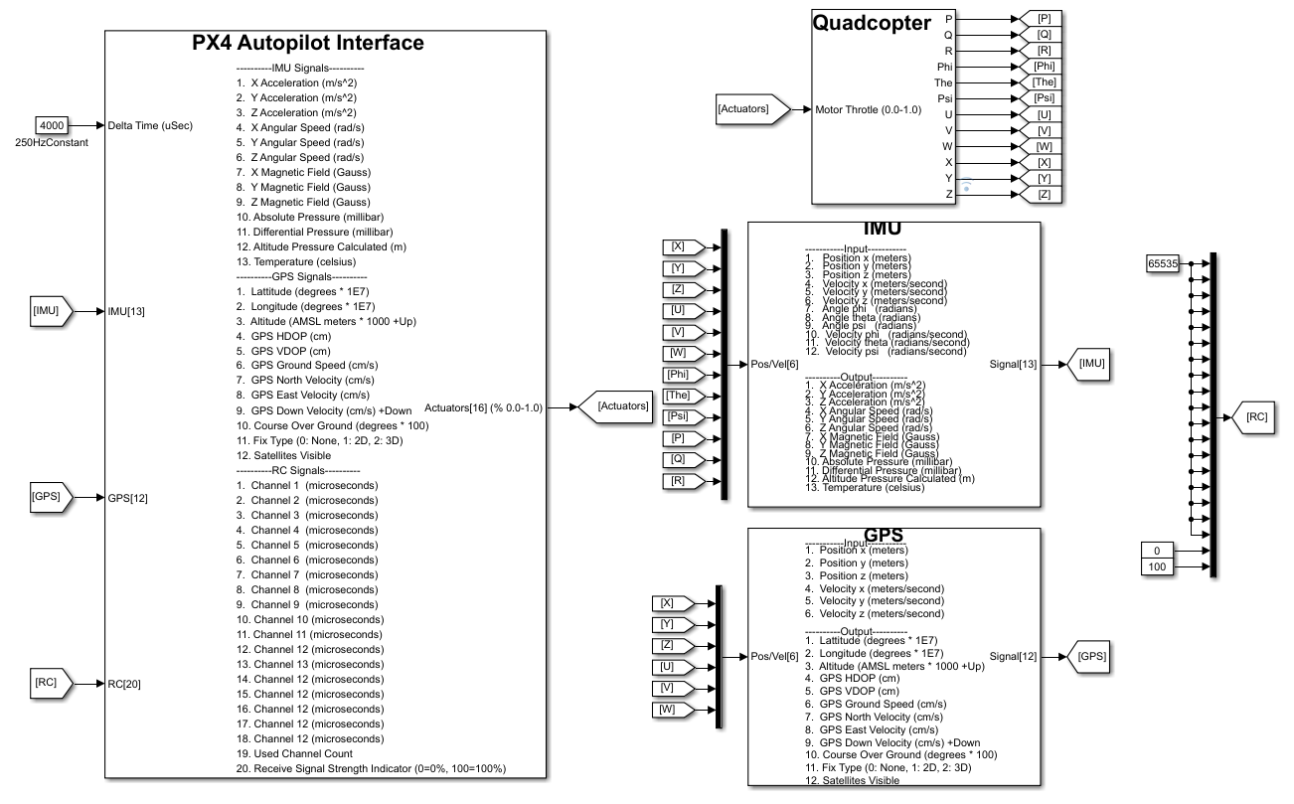

With the Simulink model created, it can then be run and controlled by a SITL PX4 autpilot as shown below. This image was captured on a Windows 10 computer. The computer has Simulink and VirtualBox installed. Ubuntu is being run in VirtualBox. Ubuntu has the SITL PX4 autopilot and QGroundControl installed. In the image below. The left half is VirtualBox running Ubuntu, with QGroundControl on top and SITL PX4 autopilot command line interface (CLI) on the bottom. The right half is Windows running Simulink, with the simulation block diagram on top and the simulation’s signal analysis on the bottom.

This image was captured after the vehicle had completed a simple mission. As can be seen in the signal analysis plot for the vehicle’s altitude. The mission consisted of a takeoff, short hover at 5ft, longer hover at 10ft, and finally a landing.

When the Simulink simulation is run, the SITL PX4 autopilot CLI begins to update, indicating that it is communicating with the Simulink simulation. After the CLI outputs “EKF commencing GPS fusion”, the vehicle is ready to fly a mission. At that point, on the QGroundControl window, the start mission option was selected. As the vehicle flies its mission, updates are displayed on the SITL PX4 CLI, indicating “Takeoff detected” and “Landing detected”.

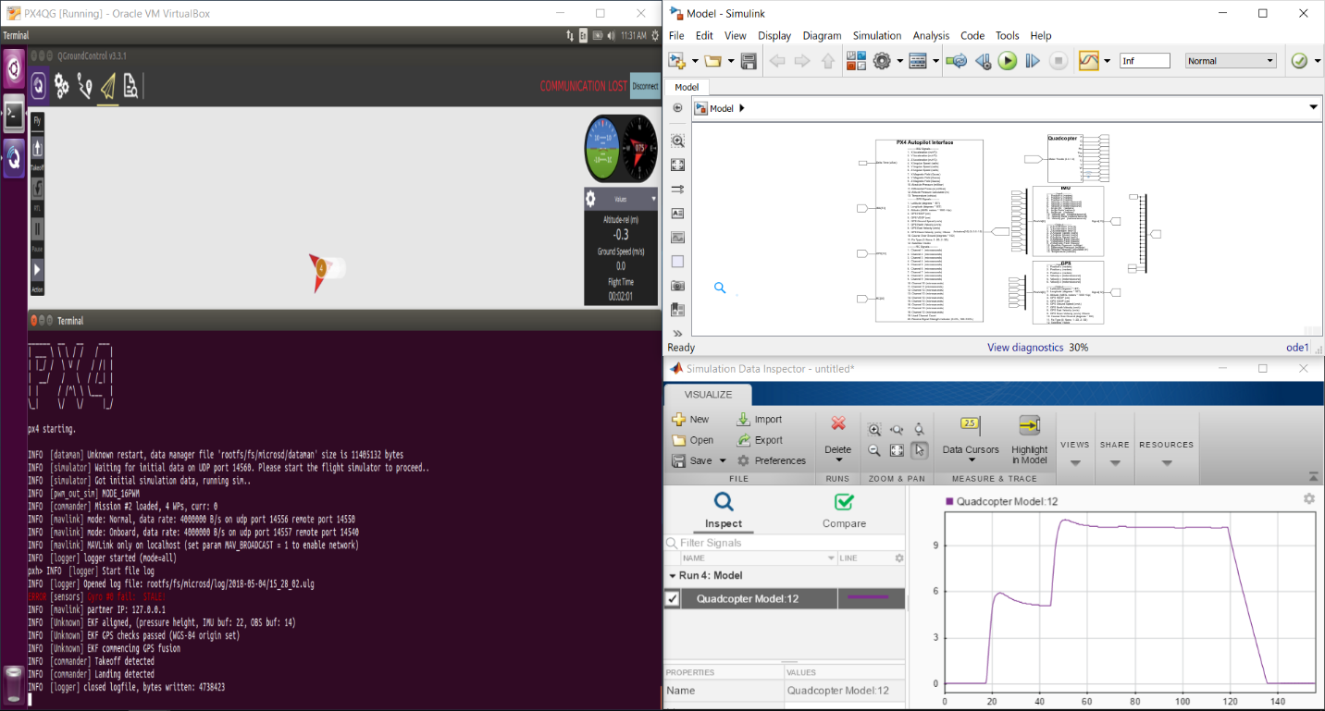

Below is a diagram of the communication between the Simulink S-Function PX4 Autopilot Interface, the SITL PX4 autopilot, and the ground control station. All communication are via MAVLink over UDP on an IP network connected as shown in the diagram below. This example runs on a single Windows computer—Ubuntu could also be run on a separate machine.

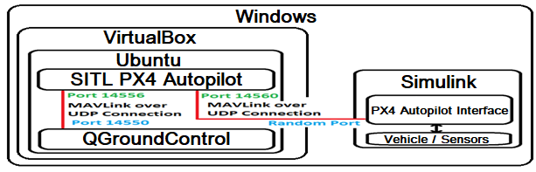

Note: The current implementation of the PX4 Autopilot Simulink Interface requires the SITL PX4 autopilot to be on IP address 192.168.46.2.